**Nightlife in Toronto, According to Bike Share Ridership**

I came across the blog I Quant NY (http://iquantny.tumblr.com/) while listening to an episode of Partially Derivative (http://partiallyderivative.com/), where the author, Ben Wellington (https://about.me/benwellington), was interviewed. He has quite a few posts based on Citi Bike data in New York. Turns out you can learn a lot from bike share ridership!

Being new to Toronto, I thought I’d follow the lead of I Quant NY and do my own analysis based on Toronto’s Bike Share data, which is openly available on Toronto’s Open Data Catalogue (<https://www.toronto.ca/city-government/data-research-maps/open-data/open-data-catalogue/#343faeaa-c920-57d6-6a75-969181b6cbde>). The question I want to answer, as a new Torontonian? Where do people go to party?

To do this, I looked at the percentage of departures between 12 am and 4 am. I focussed on ridership in Q3 2016, i.e. July to September. I wasn’t particular about choosing between weekend and weekday trips. I figure people go out whenever they want. A lot of workplaces seem to have work from home policies one day a week, so it’s possible that people may take advantage of that to go out during the week. I wouldn’t, but who knows!

I also took a look at the proportion of late night departures done by members versus casual riders. Here’s what I found:

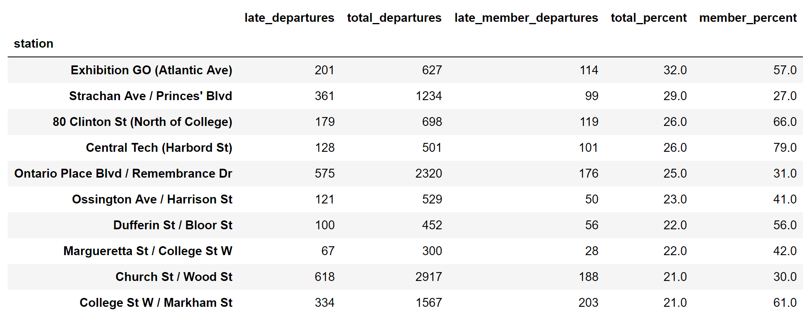

The columns in this table are:

* Late_departures: Number of departures between 12 am and 4 am.
* Total_departures: Total departures, any time of the day
* Late_member_departures. Number of late night departures done by members.
* Total_percent: Percent of departures that are late night. Late_departures/total_departures.
* Member_percent: Percentage of late night departures by members. Late_member_departures/late_departures.

What I found was, the most popular late night spots are the Exhibition GO station (Liberty Village), Strachan Ave/Princes' Boulevard (the waterfront), Little Italy, Bloor and Bathurst, and Ontario Place, where there seems to be a lot of parties/night activity.

The waterfront and Ontario place have the lowest percentage of member ridership during late night hours, and a higher percentage of casual riders. This could mean a few things. Either people are ok with hopping on a bike at these locations while a bit (or very?) inebriated, or people are quite sober and consciously make a decision to bike home. To get home, do these people need to bike for a long time, or do they live quite close? Do they go to another destination to keep on partying? This would be something to look at in a future analysis.

In Little Italy and south of Bloor Street, there’s a higher percentage of late night member ridership. I take this to mean that since these are more residential areas, non members just walk home from their night out, rather than bike. Members would be the ones who may live a bit further, just out of walking distance, or they simply want to take advantage of their membership to bike home.

Whatever the case is, it seems like I’ve identified some good nightlife locations in Toronto, in particular during the summer. I guess I’ll have to wait a few months and see how it really is!